EXPT NO:6 | IMPLEMENTATION OF MULTIVARIATE DISPLAYS
DATE: 24.01.2026

PRE-LAB QUESTIONS
- Why are multivariate displays important in AI analytics?
Answer: Multivariate displays help visualize relationships among multiple variables simultaneously, which is essential for understanding complex data in AI analytics.
- How do parallel coordinates differ from scatter plots?
Answer: Scatter plots show relationships between two variables, while parallel coordinates visualize multiple variables at once for each data record.
- What challenges exist in interpreting multivariate plots?
Answer: Overlapping data lines and clutter can make patterns difficult to interpret in large datasets.
- Where are trellis displays commonly used?
Answer: Trellis displays are commonly used for comparing subsets of data across different categories or regions.
- How does multivariate visualization aid model evaluation?
Answer: It helps identify variable interactions and trends that influence model performance.

OBJECTIVE : To implement advanced multivariate displays for complex data analysis.

SCENARIO A retail analytics firm studies sales, profit, customer segment, and region to optimize business strategy.

IN-LAB TASKS (Using R Language) • Create parallel coordinate plots • Generate bubble charts • Implement trellis displays by region

Code:

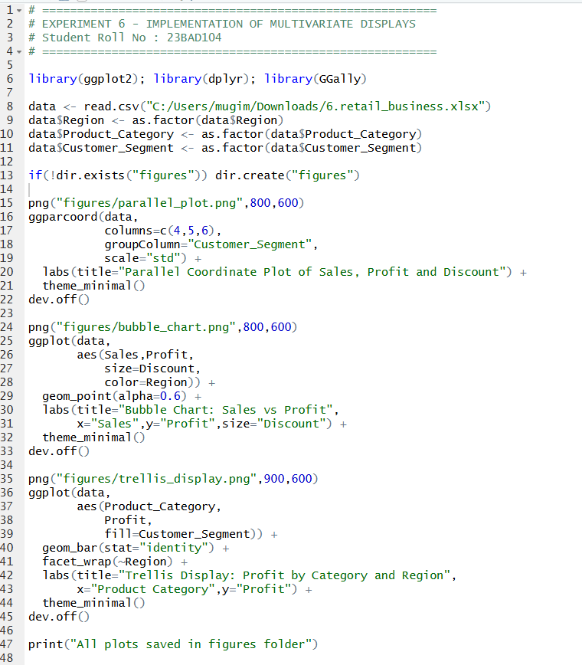

Output:
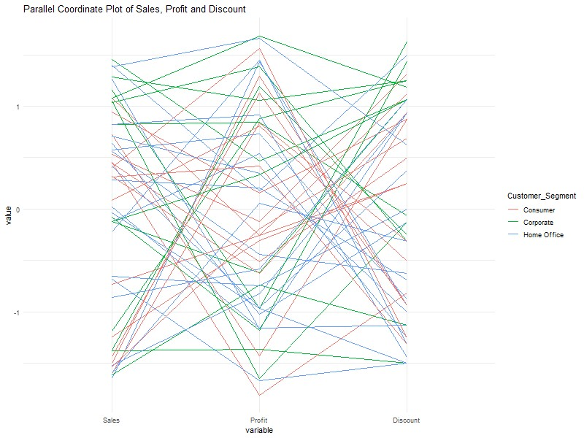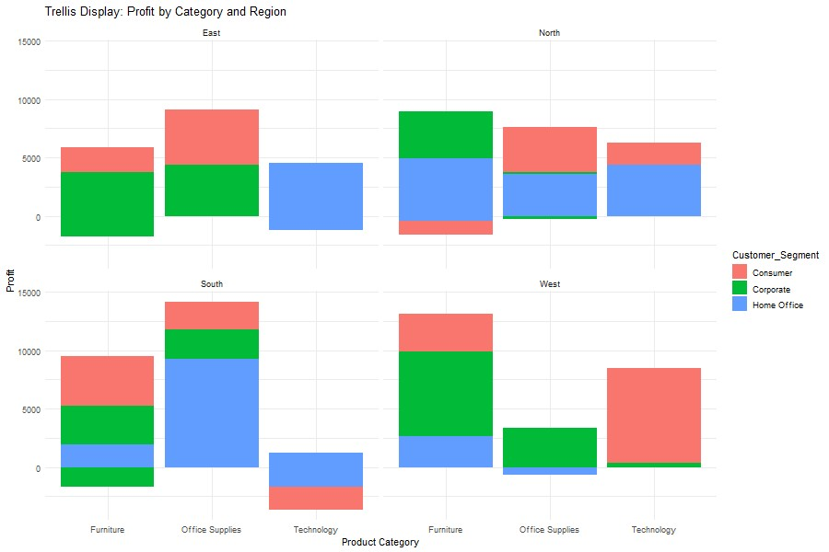

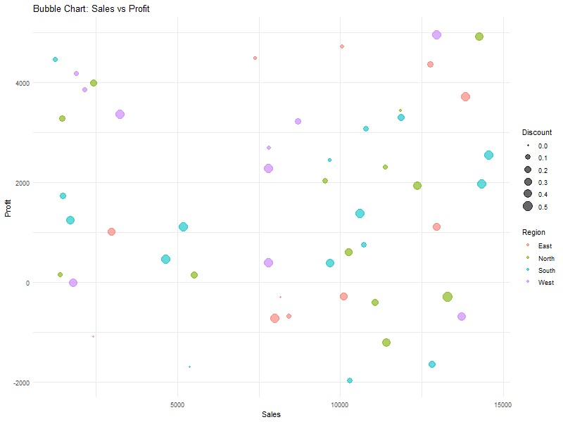

POST-LAB QUESTIONS
- What insights are gained from parallel coordinates?
Answer: The parallel coordinate plot shows how Sales, Profit, and Discount vary together for different customer segments. It reveals that high discounts do not always lead to high profits and that customer segments behave differently across these variables.
- How does faceting simplify complex data?
Answer: The trellis display splits profit data by region, making it easy to compare product category performance across East, West, North, and South regions.
- What limitations exist in bubble charts?
Answer: In the bubble chart, overlapping bubbles make it difficult to distinguish some data points when sales and profit values are close.
- How can these displays support AI-driven recommendations?
Answer: These visualizations highlight profitable regions, categories, and discount patterns, which can be used by AI models to recommend better pricing and sales strategies.
- Suggest improvements for large multivariate datasets.
Answer: Using interactive plots with zooming and filtering can reduce clutter and improve analysis for large datasets.

ASSESSMENT

Description |  | Max Marks | Marks Awarded
Pre Lab Exercise |  | 5
In Lab Exercise |  | 10
Post Lab Exercise |  | 5
Viva |  | 10
 | Total | 30
 | Faculty Signature

